**Pass Through Authentication**

What is Pass Through Authentication?

Pass Through Authentication allow users to sign-in both on-premise and cloud-based applications using the same passwords.

In Pass-through Authentication users are authenticated from On-premise Active Directory.

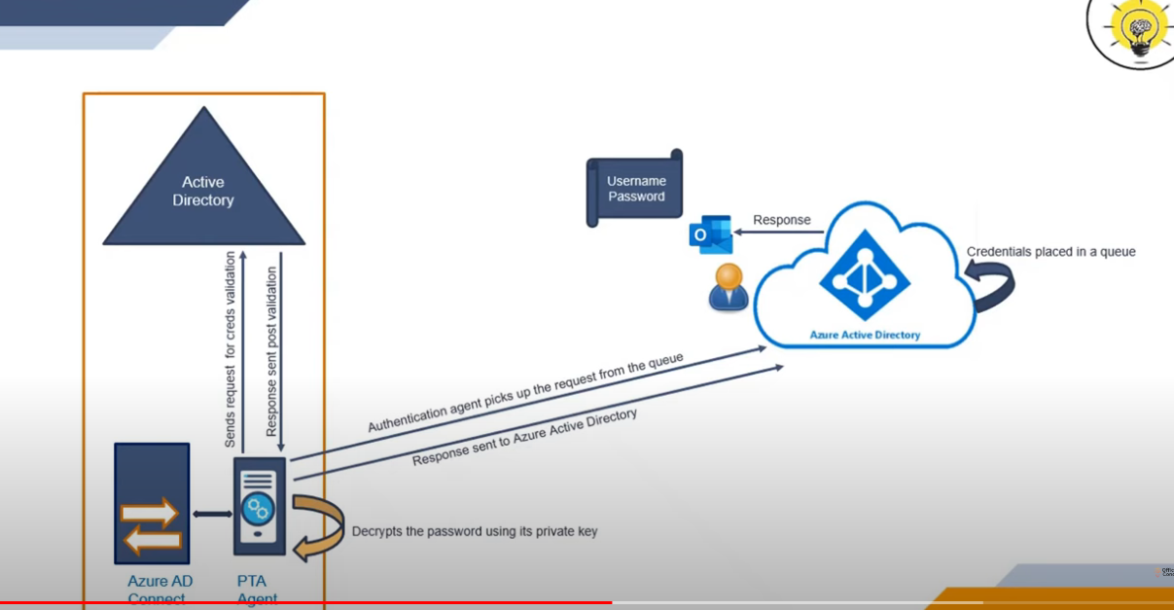

In this Pass through Authentication first the users are sync from on-Prem Active Directory to Azure Active Directory using **AAD Connect** when the user try to login any of the service such as Outlook.com have to provide the username and password for Authentication the Azure Active Directory will Encrypt the password using the Public key of **Pass through Authentication Agent** and sends the request to the queue and when the Authentication agent picks the request from the queue it will decrypt the password using the private key and sends the requests for credential validation to the on-Prem Active Directory will validate the request and send post validation to the Pass throught Authentication agent and the Agent will sent the Response to Azure Active Directory and AAD will response to the user in the form of Login Successful, Password Expires or User Logout.

You can enable Pass through Authentication in Two ways:

You can modify the sign-in options in AAD Connect and also enable during the fresh installation of AAD Connect.